**Definition and Acronym**  
**Computerized System**: The system that accomplish by using a machine or computer either for specific purpose or general purpose.

**End user:** are users that access the system as an ultimate user.

**Front end**: is a layer that is the presentation layer.

**Back end:** is the layer that is the data access layer.

**Acronym**

ASTU………………………Adama science and technology university

OBSA…………………………online bidding system for ASTU

DB……………………….…… database

HTML…………………………Hyper Text Markup Language

CSS………………..……………Cascading Style Sheet

GB………………………………Giga Byte

RAM…..........................Random Access Memory

SQL……………………..……. Structural Query Language

PHP……………………….…. Hypertext Processor

UML…..........................Unified Modeling Language

LAN……………………..……local area network

**4.2 Proposed system architecture**  
 **4.2.1 Overview**

Our proposed system is mainly developed in accordance to the SRS documentation, here in this proposed system architecture we will decompose the system that is the subsystem decomposition and it deals with how the system is decomposed to individual subsystems that can be integrated together to give the overall system function. another key point in the system design is the hardware/software mapping this is the way how software’s and hardware’s are going to be mapped in order to achieve goals of the system. Another thing that is going to be involved here is the persistent data management this is the way of representing how the data are stored or managed. (how persistent data like database, files are stored and managed). the other to be illustrated here is the access control and security this is all about who have access to which area of the network so that the security of the system is preserved and preventing unauthorized party access. Finally, this part focuses on boundary conditions this are how the system is brought from uninitialized state to initialized state and to working condition. 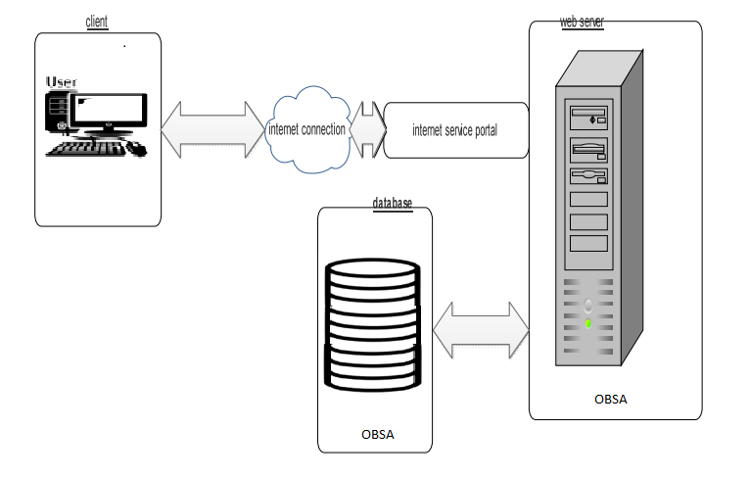

**4.2. Current Software Architecture**

In this project we have decided to **use three-tier architecture** which has three layers

Namely

* **Client side**: here in the client-side service seekers, bid committee, advertiser, bidder and casher user interface will be existing.
* **Server side:** here the web servers to connect the data base application are found
* **Data base**: here the data bases that store the information are found.

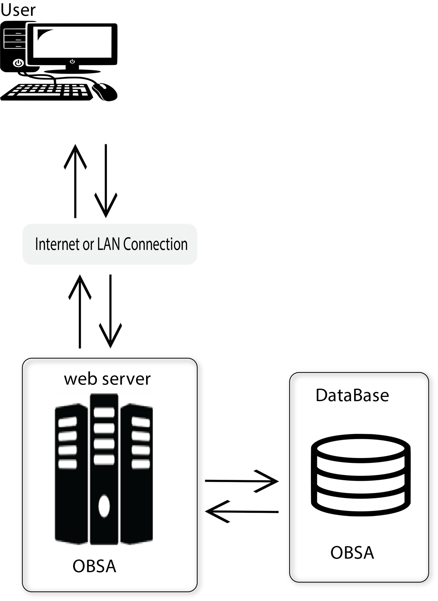

**4.2.2. Subsystem decomposition**

As this system is made to meet the functional requirements and also meet the desired goal we divided the whole system into parts, this broken down pieces or parts are called subsystems of our system. These subsystems are like a module and will be able to be developed individually or independently so that the integration of this subsystems can give the main system. our system has 6 subsystems.

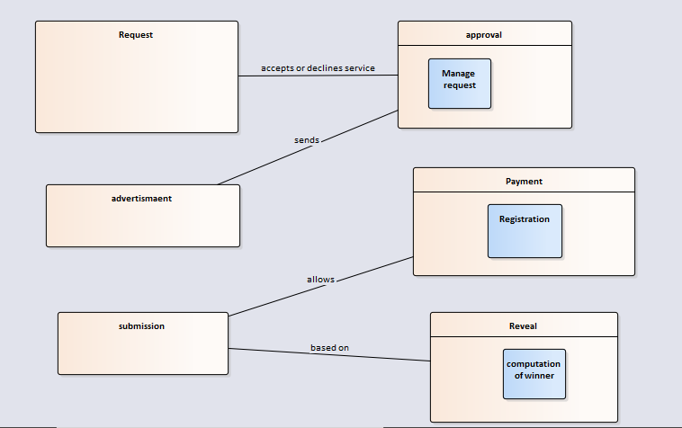

**Subsystem decomposition description**

|  |  |  |
| --- | --- | --- |
| **subsystem** | **Purpose** | **Class** |
| **Request** | **It’s a platform for the service seekers to request the bid committee a product or service.** | **Service seeker, bid committee,service** |
| **Approval** | **Responsible for the bid committee approval of the service requested and directing of the advertisement agents about the description of the requested product or service to be advertised.** | **Bid committee, advertisers, bid,approval** |
| **Advertisement** | **Responsible for the bid advertisement for eligible and interested bidders.** | **Advertisers, Bidders** |
| **Payment** | **Is responsible for the registration of eligible bidders for a submission of bid document upon required payment and CPO document.** | **Casher, Bidders** |
| **Submission** | **Responsible for the submission of the full required document for the advertised bid.** | **Bidder , Form** |
| **Reveal** | **It is a subsystem responsible for computing the bid winner and revealing the winner to the authorized party.** | **Bid** |